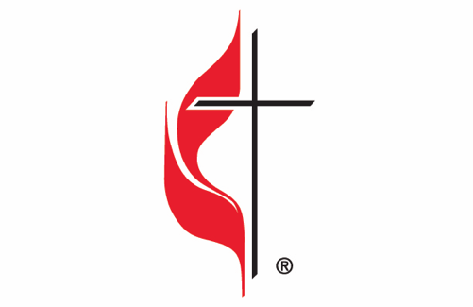
Grace United Methodist Church
21 S. Franklin Ave.
Valley Stream, NY 11580
www.gracevsny.org

Director of Music
Position Description
Job Title: Director of Music, Organist, and Chancel Choir Director
Reports to: Pastor and the Staff/Pastor-Parish Relations (SPPR) Committee
Classification: Part Time – approximately 20 hours a week. $35K per year.

Summary:
Grace United Methodist Church in Valley Stream, New York, is seeking a dedicated and passionate Director of Music, Organist, and Chancel Choir Director. The ideal candidate will lead people of all ages in the congregation in music-making experiences to help them grow in their Christian faith, strengthen their relationship with God, and gain music skills for effective service in the church.

The Director of Music will manage the ongoing needs of the music program, arrange for and lead choirs, and schedule and manage special music as required. The Director will work in partnership with the Pastor and communicate the music vision to the Worship Committee.

Principal Duties and Tasks:
Sunday Worship and Special Services: Provide musical leadership and accompaniment for all Sunday Worship Services and special worship services (including Ash Wednesday, Wednesday evening Lenten Services, Holy Thursday, two Good Friday services, two Christmas Eve services, Music Sunday, and the Christmas Concert).
Chancel Choir Leadership: Direct the Chancel Choir and related musicians, both vocal and instrumental. Lead and accompany the Chancel Choir at weekly rehearsals from September to June and prepare for special services.
Volunteer Recruitment: Recruit and motivate volunteers to participate in the Chancel Choir and other musical groups within the church.
Special Music Arrangements: Arrange for soloists or other musical offerings for Sunday worship services when the Chancel Choir is not singing and for Lenten services. Accompany soloists and other musical ensembles as needed.
Weddings and Funerals: Provide musical services for weddings and funerals, if available (on a first refusal basis, with a fee provided).
Additional Services: Provide musical services for special events and worship services not listed above, if requested and available (e.g., Prayer Breakfast, with a fee provided). ∙ Music Program Management: Oversee ensembles, instrumentalists, soloists, and choirs. Prepare the music calendar and ensure proper coordination for weekly worship services.
Collaboration and Meetings: Collaborates with the Senior Pastor and worship team in the development of Sunday morning worship, occasional, and special services. Attend and participate in Worship Committee meetings and Church Council meetings when possible.
Replacement Arrangements: Arrange for a replacement organist when absent.
Budget Management: Submit an annual itemized budget to the Finance Committee and monitor expenditures of the music budget throughout the year.
Maintenance and Purchases: Arrange for music and music-related purchases and expenditures as needed. Develop and monitor a maintenance schedule for the music program, including the music library, robes, piano, organ, hand bells, and other musical instruments and equipment.
Order of Worship: Submit the music information needed for the weekly Order of Worship to the church administrator within established weekly deadlines.
Innovation and Creativity: Encourage innovation and creativity in the music ministry.
Copyright Adherence: Adhere to all copyright laws regarding use, licensing, and distribution of music.
Qualifications:
- Proven experience in church music ministry, including leading choirs and playing the organ.
- Strong understanding of the Christian faith and music’s role in worship.
- Ability to recruit, motivate, and lead volunteers in the music program.
- Excellent communication and organizational skills.
- Familiarity with copyright laws related to music use and distribution.
- Ability to collaborate effectively with church staff and committees.

Application Process:
Interested candidates should submit a resume, cover letter, and references to gracevsny@gmail.com by October 31, 2024.

Grace United Methodist Church is an equal opportunity employer and welcomes applications from all qualified candidates.

This job posting is designed to attract qualified candidates who are passionate about leading a vibrant music ministry and contributing to the spiritual growth of our congregation through music.

